Read every day tor at least 20 minutes each day then complete one of the following

- Design a new cover for the book you are currently reading. Remember to include the key features of a book cover.
- Draw a picture of the Main Character from your book. It should take up a page and include as much detail as possible.
- Create a timeline of the events as they occur in your book.
- The short description on the back of a book is called the Blurb, write a new blurb for your book if it does not have one create one.
- Create a new beginning for your book. It should be at least ¾ of a page. Write the line in the story where your new beginning joins the book.
- Create an advert for your book that will make people want to read your book. The advert could be for a Newspaper, Magazine or the internet.
- Choose the main event that occurred in your story and create an alternative. How did this alternative event affect the rest of the story?
- Create a Map that shows the main locations in your book and how they are located to each other. Use as many map features as you can.
- Describe a character in your book without any pictures to someone who has not read the book, you will need to include both looks, personality, and traits.
- Who was the author of your book? You will need to do some research on the author and create a page that describes as much about them as you can. Name, age, other books they have written, where they live, what they like, do they have a family… As much information as you can.
- Create a new character that could realistically fit in the story without adjusting the main plot.

Persuasive Prompts

I should be able to go to bed when I want.
All classrooms should have a class pet.
There needs to a be a non-school uniform day every week.
You can only eat apples or oranges for the next week. Which one will you eat? Why?
I should be allowed to stay home alone.
There should be no homework at school.
Break times at school should be longer.
People should be fined for dropping litter.
I should be allowed to eat ice cream every day.
All students should learn how to cook.
Persuade your family to let you open a birthday present the day before your birthday.
Persuade your family to give you twice as much pocket money.
If you could have any pet, what would it be? Convince your family why you should care for it.
Convince your friend to swap their packed lunch with yours.
Students should be allowed to pick their own seats in class.
Persuade your family to watch the film you want to watch.
Dogs are better than cats.
School holidays should be longer.
Imagine in the future, you can live on land or underwater. Which one would you choose? Why?
You have to live in another country. Which one do you choose? Why?
Convince your family to let you watch your favourite TV programme.
Students should be allowed to choose their teacher.
Students should have 3-day weekends.
You can only play one sport for the next month. What is it? Why?
Students who are late to school should do a chore for their class.
You can choose one superhero power to help others: fly or stop time. Which one do you choose? Why?

Spelling
Sentences  Place each of the words into a sentence  Underline your list word | Short Story  Write a short story that contains all of your list words | Colour vowels  Write your words the vowels in a different colour. | Odd One Out  For each of your words, write four words. One is your spelling word, two relate to your spelling word and one is the odd word out, it does not fit with the others. | Syllable sort  Write your words in order from the least amount of syllables to the most. Words with the same number of syllables should be in alphabetical order.
Synonyms  Write your spelling words once. Next to each word write a synonym (a different word with the same meaning). | Pyramids  Use your words to make spelling pyramids  Adding one letter each time. E.g.  W  Wr  Wri  Writ  Write | Left and right  Write your spelling words once with your left hand and once with your left hand | Upper and Lower case  Write your words in upper and then in lower case. | Colourful words  Write each of your words in different colours
Pictures  Draw a picture to represent each of your words. Remember drawings should be in pencil | Dictionary meanings  Use a dictionary (online or book) to find the definition for each of your spelling words. Copy the best meaning for your word out. | Words within words  Make a list of as many smaller words as you can find in your list words. E.g. Word -or | Cut out words  Cut your words out of magazines or newspapers and stick them on a sheet if you can’t find the letters and make your words. | Codebreaker  Write your words in code.

Maths
At-Home Investigation
Come up with a plan to measure the perimeter of your lounge room and your bedroom My plan: answer these questions
• Look at the lengths that you will have to measure for each room.
What problems can you see?
Come up with a plan for measuring the length of each wall without having to move your furniture.
• How will I make sure that I am measuring accurately when there is furniture in the way?
What would happen if I didn’t measure straight along?
Carry out my plan: follow these steps and answer the questions
• Measure each room and calculate the perimeter.
Explain how you did it in the space below and give the final measurement for each.
Extend your learning: follow this step and answer the question How would you write the perimeter of each room in centimetres? How about millimetres?

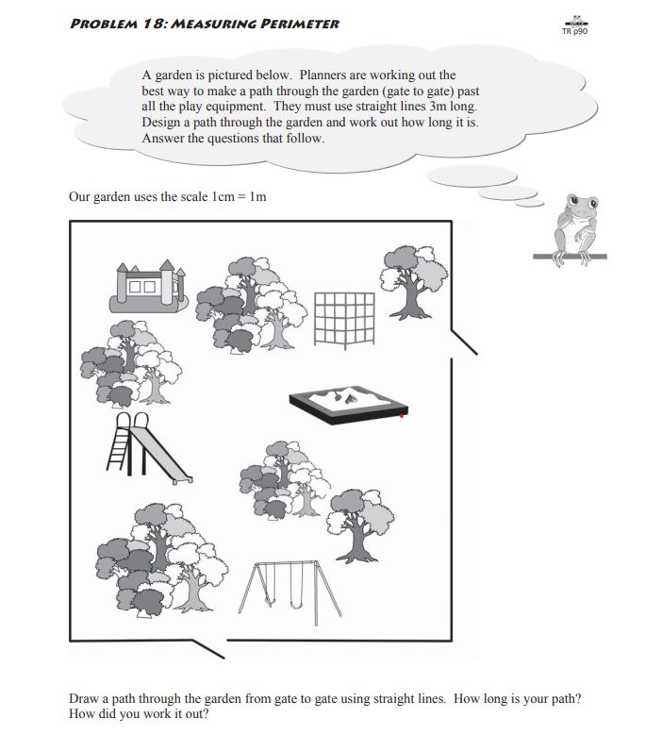
Now join your path back up to the start instead of going out the second gate. Use a different colour. The length of this path is called the perimeter. Work out the perimeter of your revised path. What is it and how did you work it out?

